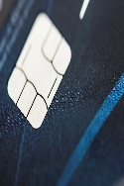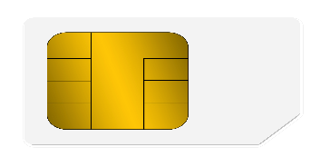

NAME SURNAME

00/00

1234 4568 1234 4568

**Bankk**

Debit Card Cac Car